<https://www.teaandcoffee.net/feature/25845/awakening-to-the-potential-of-artificial-intelligence-in-coffee/>

The computer science researchers Alexandre Pereira Marcos, Natan Luis Silva Rodovalho, and André R Backes at The Federal University of Uberlandia, Brazil, are currently training a Convolutional Neural Network (CNN) to identify coffee leaf rust. The spray robot would use image processing and machine learning to identify which leaves are contaminated with coffee leaf rust, and in turn, isolate which plants need to be treated. The current model was able to detect the leaves that were impacted by coffee leaf rust, but also reported that the areas surrounding the leaves were infected.

<https://www.ajol.info/index.php/ajfand/article/view/266118>

I. Santoso, “Application of digital image processing method for roasted coffee bean quality identification: A systematic literature review,” African Journal of Food, Agriculture, Nutrition, and Development, vol. 24 no. 1, 25264-25287, 2024.

Parameters for evaluating the quality of roasted coffee

1. Color parameters: Red Green Blue (RGB), Grayscale, Hue Saturation Intensity (HSI), and L\*a\*b\* features.

2. Texture parameters: energy, entropy, homogeneity, and contrast.

3. Shape parameters: area, circumference, diameter, and percentage of roundness.

The main parameter is the color parameter.

The image processing methods used for quality classification include Backpropagation (BP), Learning Vector Quantization (LVQ), and K-Nearest Neighbor (KNN). The best method for classifying the quality of roasting results is Backpropagation.

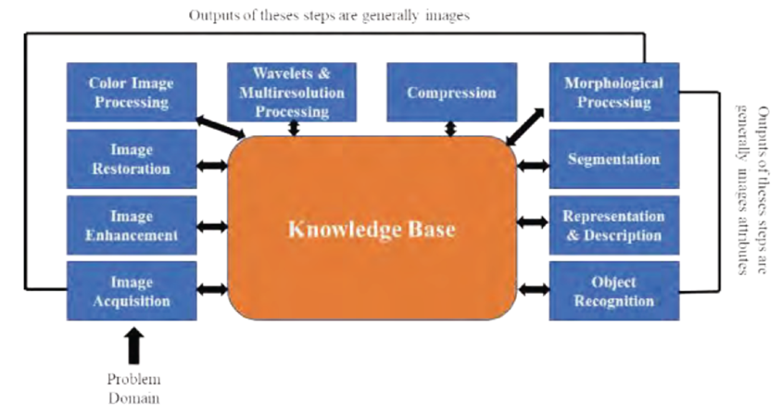

The fundamental steps in digital image processing.

Muktar Bedaso Kuyu, Million Meshesha, and Chala Diriba, Grading Ethiopian Coffee Raw Quality Using Image Processing Techniques.

<https://www.researchgate.net/publication/362909990_Grading_Ethiopian_Coffee_Raw_Quality_Using_Image_Processing_Techniques>

